Jigsaw Database

John Wensink

MIS407 Database Analysis and Design

Colorado State University-Global Campus

Nathan Braun

July 21, 2019

I have successfully installed PostgreSQL, created the Jigsaw (js) database, and populated the tables with “js_data.sql”.

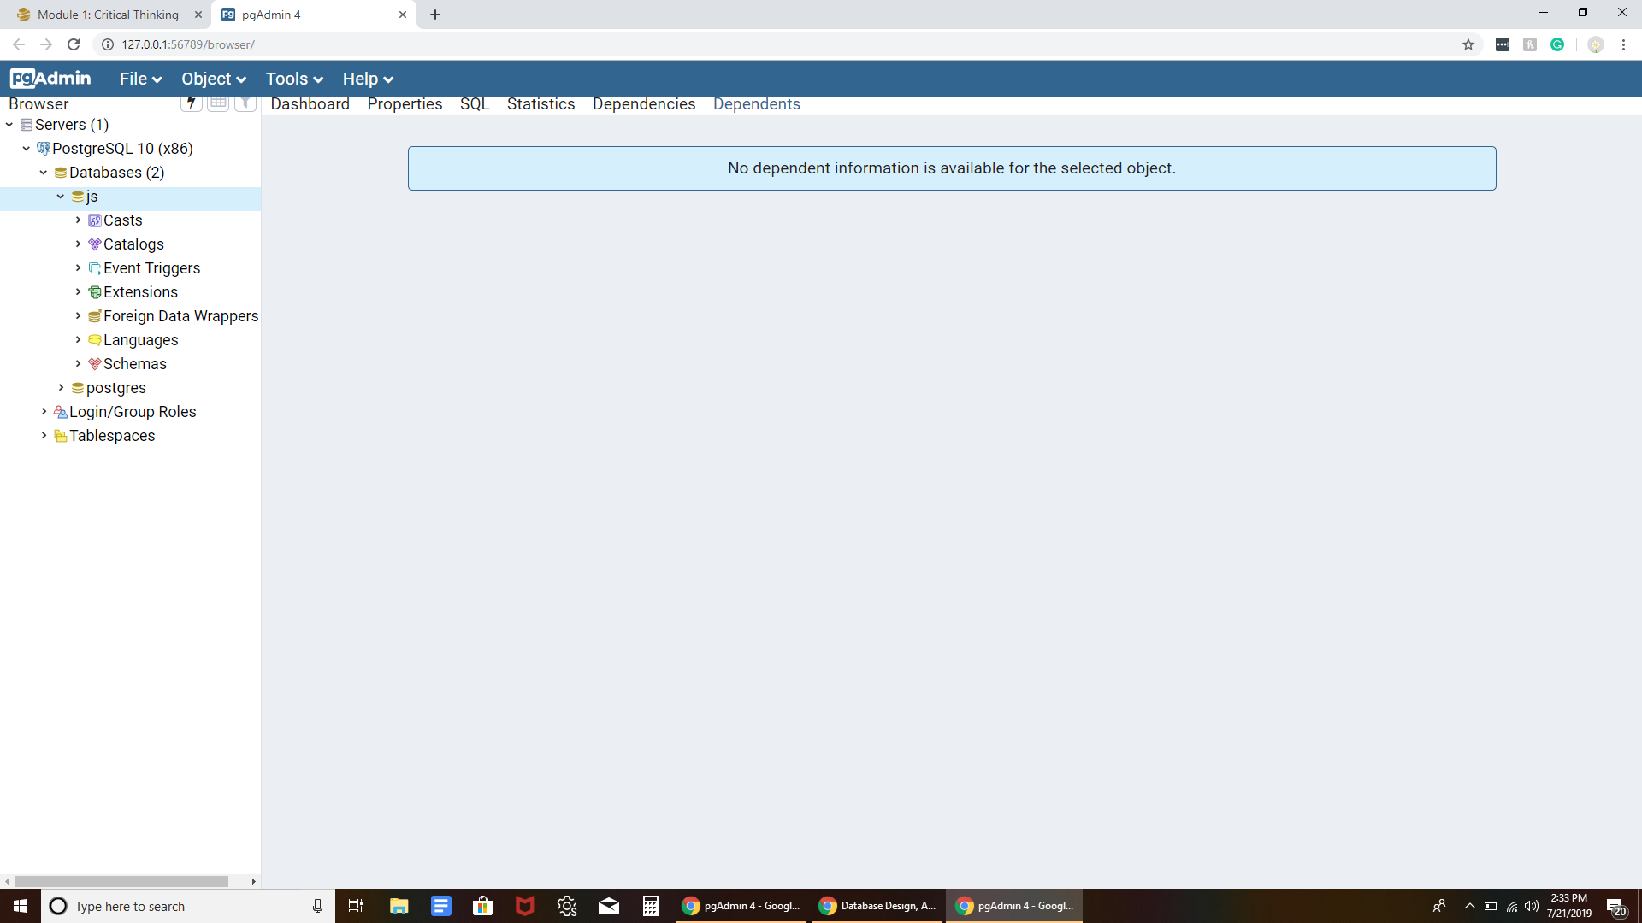

1. PostgreSQL successful installation

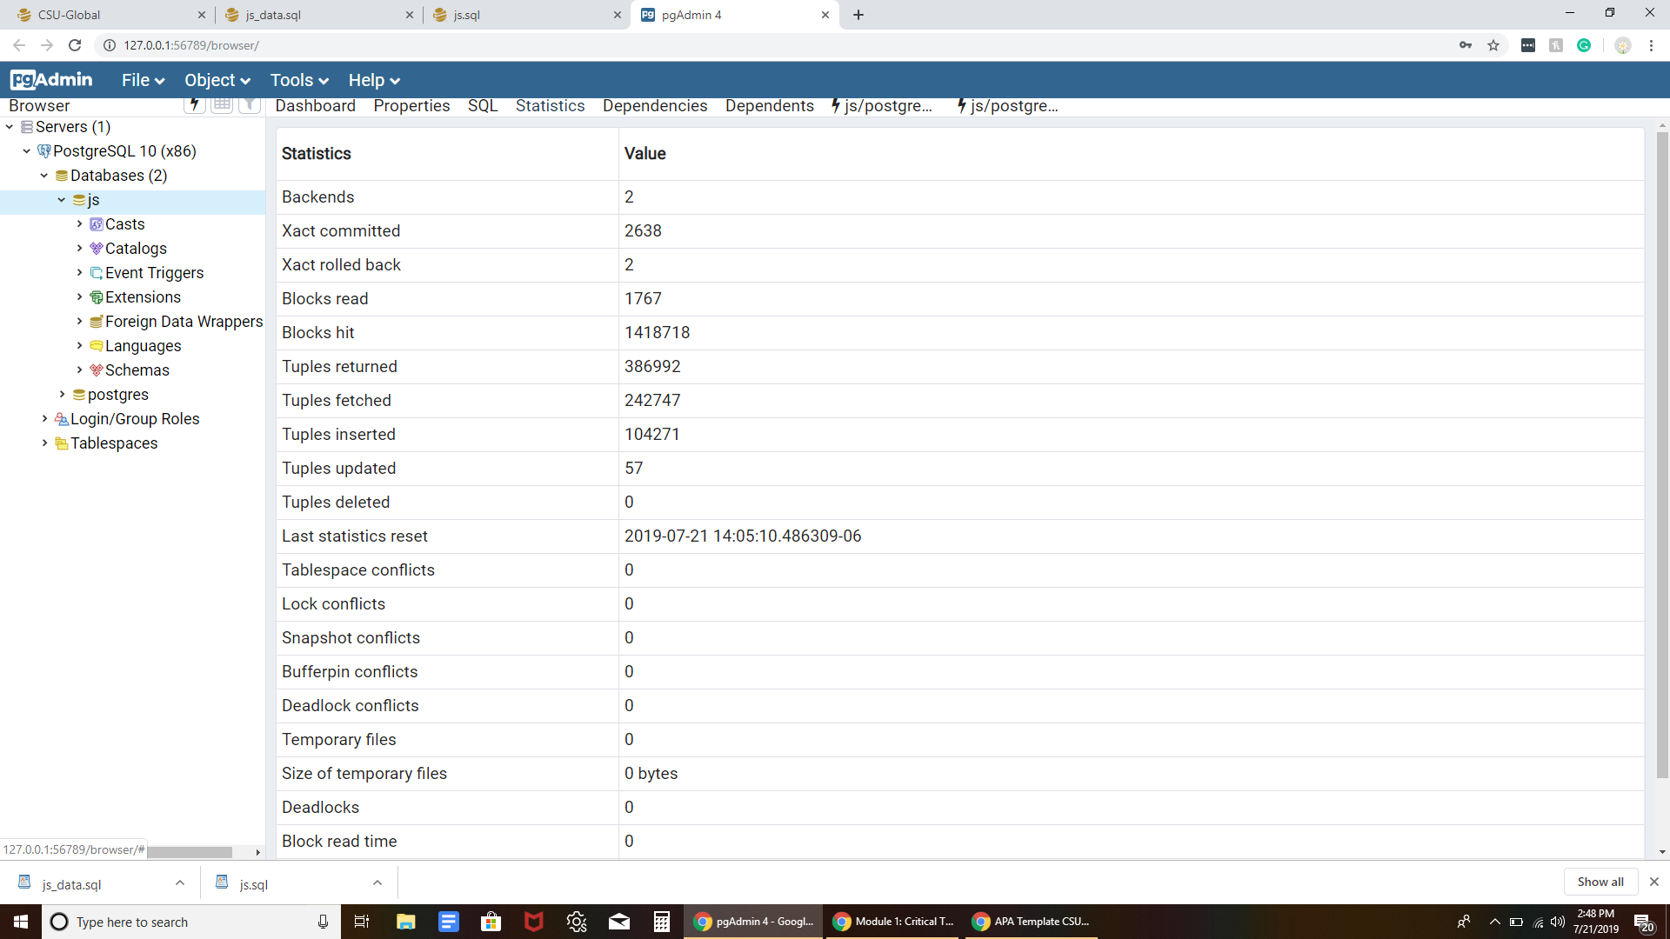2.) Jigsaw (js) tables installed successfully

Hello Professor Braun, I am happy to have the good fortune to have had you as an instructor in my previous MIS300 class. That was one of my favorite classes I’ve had yet at CSU-Global and I couldn’t be more excited to take a deeper dive into database analysis and design. I had gotten thru 75% of this week’s required readings before noticing that today’s critical thinking assignment did not require any sort of technical knowledge of database concepts. I was pleased to find the Mannino text was easy to read and that its scope was pretty close to the level of learning I am prepared for. MIS300 did an excellent job in preparing me for the more advanced concepts that will be presented this trimester. I can not say the same about the Juba/Volkov text. From the first few pages, I felt unfamiliar and unprepared for the material. I am not deterred. I have dedicated double the amount of time per week that I would normally take for a more intuitive class, and my family is on board with the slight reduction in family-time that will be required to fully understand the material.

This week my curiosity was piqued when I read about distributed and physical database design, tuning, analysis, and optimization. I think the hard skills involved in mastering these topics will be right up my alley, as I prefer technical work with computer programs over creating conceptual ER diagrams, logical data flow, and data modeling. I completed this week’s critical thinking assignment and have spent the last hour exploring PostgreSQL, I may need to re-install and re-populate the database as I have no idea what I’m doing and have probably corrupted some information that will be used in future assignments. I’m taking advantage of the RedShelf formatted text and making flashcards for all the key concepts that sound like they will be important. My previous class was a Principles of Management course that I found little value in. Now that I’m back in an information technology class my thirst for knowledge is back and I am truly looking forward to putting in the hours to understand this discipline. Here are some topics I learned about this week that I find extremely interesting:

* Efficiency due to a properly built distributed/physical database design.
* Direct conversion from Entity-Relationship Diagrams into database tables by using a Computer-Aided Software Design (CASE) system.
* The decision making process as it applies to logical clustering of data.
* View Design as it applies to massive database development.
* Prototyping database systems before their completion.
* NoSQL and how it can be used to augment SQL.
* When it makes sense to index a column and when it does not.
* Application development that is compatible with PostgreSQL
* Normalization, and what situations might cause it to be inappropriate.

One of the side-projects I have been working on involves writing stock trading algorithms in Python and I think I will try to make an archive of historical market data using the skills taught in this course. I don’t pretend that any of my algos even work, let alone are profitable, but it is something that I’m passionate about where I can apply the skills I’m learning at CSU-Global.